

**COMSATS UNIVERSITY ISLAMABAD**

**Web Technologies**

**Theory ASSIGNMENT # 1**

**SUBMITTED BY:**

* MUHAMMAD ATIF (**SP21-BSE-052**)
* TANZEEL UR REHMAN (**SP21-BSE-087**)

**SUBMITTED TO:**

**DR. Hasnain Iqbal**

**Home Page Code:**

<!DOCTYPE html>

<html lang="en">

<head>

    <meta charset="UTF-8">

    <meta name="viewport" content="width=device-width, initial-scale=1.0">

    <title>Student Online Portal</title>

    <link rel="stylesheet" href="homeStyle.css">

    <link rel="stylesheet" href="product.html">

</head>

<body>

    <header>

        <div class="navbar">

            <div class="logo">

                <div class="l">

                     <img src="background.jpg" height="80px" width="70%" class="i"/>

                </div>

                 <div class="n" >

                   <span style="color: #8AC6FF; font-size: x-large;">Student Portal</span>

                 </div>

            </div>

            <div class="icons">

                <ul class="headerLu">

                        <li class="headerLi"><a href="#">HOME</a></li>

                        <li class="headerLi"><a href="product.html">PRODUCTS</a></li>

                        <li class="headerLi"><a href="#">ABOUT</a></li>

                        <li class="headerLi"><a href="#">CONTACT</a></li>

                </ul>

            </div>

           <div class="auth">

              <button class="Login">Login</button>

              <button class="Sign">Sign up</button>

           </div>

        </div>

    </header>

    <h1>Online Student Portal</h1>

    <h3>Introduction: </h3>

    <p><pre>The Student Online Portal is a web-based application

designed to provide a convenient platform for students to

access various educational resources, interact with

instructors and peers, and manage their academic activities.

The portal aims to streamline communication and enhance

collaboration between students and educational institutions</pre></p>

        <h3>Actors:</h3>

        <ul>

            <li>Students</li>

            <li>Faculty</li>

            <li>Administration</li>

            <li>Parents</li>

        </ul>

        <h3>Modules:</h3>

        <ul>

            <li>

                <h4>Dashboard:</h4>

                A personalized homepage displaying important announcements, events, and quick access to frequently used modules.

            </li>

            <li>

                <h4>Profile Management:</h4>

                Allow students to update their personal information, contact details, and profile pictures.

            </li>

            <li>

                <h4>Course Information:</h4>

                View class schedules, syllabi, and access to course materials, including lecture notes, presentations, and assignments.

            </li>

            <li>

                <h4>Grades and Transcripts:</h4>

                Check grades, academic transcripts, and GPA information.

            </li>

            <li>

                <h4>Registration and Enrollment:</h4>

                Register for classes, add/drop courses, and view enrollment history.

            </li>

            <li>

                <h4>Student Services:</h4>

                Request transcripts, certificates, or other administrative services.

            </li>

            <li>

                <h4>Feedback and Surveys:</h4>

                Participate in surveys, provide feedback on courses and instructors.

            </li>

            <li>

                <h4>Support and Helpdesk:</h4>

                Access a helpdesk or support system for technical issues or general inquiries.

            </li>

            <li>

                <h4>News and Updates:</h4>

                Stay informed about campus news, events, and achievements.

            </li>

        </ul>

    <footer> Muhammad Atif (SP21-BSE-052) <br> Tanzeel-ur-Rehman (SP21-BSE-087)</footer>

</body>

</html>

**Screen Shot:**

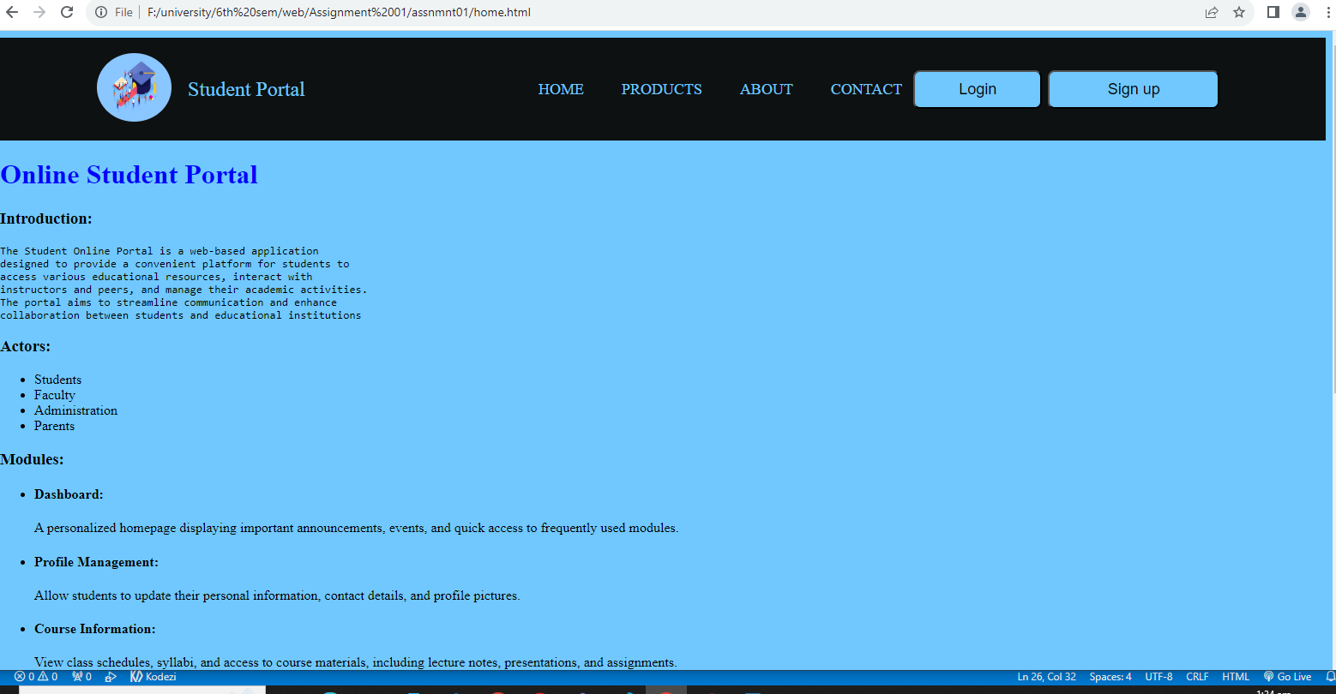

**Product page Code:**<!DOCTYPE html>

<html lang="en">

<head>

    <meta charset="UTF-8">

    <meta name="viewport" content="width=device-width, initial-scale=1.0">

    <title>Student Online Portal</title>

    <link rel="stylesheet" href="homeStyle.css">

    <link rel="stylesheet" href="home.html">

    <link rel="stylesheet" href="product.css">

</head>

<body >

    <header>

        <div class="navbar">

            <div class="logo">

                <div class="l">

                    <img src="background.jpg" height="80px" width="70%" class="i" />

                </div>

                <div class="n">

                    <span style="color: #8AC6FF; font-size: x-large;">Student Portal</span>

                </div>

            </div>

            <div class="icons">

                <ul class="headerLu">

                    <li class="headerLi"><a href="home.html">HOME</a></li>

                    <li class="headerLi"><a href="product.html">PRODUCTS</a></li>

                    <li class="headerLi"><a href="#">ABOUT</a></li>

                    <li class="headerLi"><a href="#">CONTACT</a></li>

                </ul>

            </div>

            <div class="auth">

                <button class="Login">Login</button>

                <button class="Sign">Sign up</button>

            </div>

        </div>

    </header>

    <div>

        <h2>Online Student Portal</h2>

    </div>

        <div class="shop-sec">

            <div class="polaroid">

                <img src="./productimages/dashboard.png" alt="dashboard" style="width:100%">

                <div class="container">

                  <p>Dashboard</p>

                </div>

            </div>

            <div class="polaroid">

                <img src="./productimages/courses.jpeg" alt="course" style="width:100%;height: 200px;">

                <div class="container">

                  <p>Courses</p>

                </div>

            </div>

            <div class="polaroid">

                <img src="./productimages/whatnew.png" alt="whatnew" style="width:100%;height: 200px;">

                <div class="container">

                  <p>What's New</p>

                </div>

            </div>

            <div class="polaroid">

                <img src="./productimages/survey.png" alt="survey" style="width:100% ;height: 200px;">

                <div class="container">

                  <p>Survey and Feedback</p>

                </div>

            </div>

            <div class="polaroid">

                <img src="./productimages/help.png" alt="help" style="width:100%;height: 200px;">

                <div class="container">

                  <p>Help Desk</p>

                </div>

            </div>

        </div>

    <br><br><br>

    <footer>Muhammad Atif (SP21-BSE-052) <br> Tanzeel-ur-Rehman (SP21-BSE-087)</footer>

</body>

</html>

**Screen shot :  
**

**CSS Code:**

Home:  
body{

    background-color: #8AC6FF;

    background-repeat: no-repeat;

    background-size: auto;

    background-position: top right;

}header{

    text-align-last: center;

    justify-content: space-between;

}.navbar{

    height:120px;

    background-color:#0F1111;

    display:flex;

    align-items: center;

    justify-content:space-around;

}.logo{

    display:flex;

    align-items: center;

}.i{

    border-radius:50%;

}.headerLu{

    list-style: none;

    display: flex;

}

.headerLi{

    margin-left: 15%;

}.headerLi:hover{

    scale: 0.95;

}

.Login{

    font-size: large;

    width:150px;

    height:45px;

    margin-right:7px;

    border-radius: 8px;

    background-color: #8AC6FF;

 }

 .Sign{

    font-size: large;

     width:200px;

     height:45px;

     border-radius: 8px;

     background-color: #8AC6FF;

 }

 button:hover{

    background-color: #1B9CFC;

    scale: 0.92;

 }

 .icons ul li a{

    text-decoration: none;

    font-size:18px;

    font-weight: 500;

    color:#8AC6FF

}

 .auth{

     display: flex;

     width:25%;

 }.icons ul li a{

    text-decoration: none;

    font-size:18px;

    font-weight: 500;

    color:#8AC6FF

}

h1{

    color: blue;

}

pre{

    text-decoration: none;

}a{

    font-size: large;

}

a:visited{

    color: blue;

}a:hover{

    font-size: larger;

    color: black;

}footer{

    text-align: center;

    padding-top: 10px;

    height:55px;

    margin: 100;

    color: white;

    background-color: black;

    font-weight: 800;

    font-size: large;

    text-align-last: center;

}footer:hover{

    color: #8AC6FF;

    font-size: larger;

}

Product Page CSS:  
h2{

    font-size: 40px;

    text-shadow: 1px 1px grey;

    text-align-last: center;

    text-align: center;

    padding: 70px;

    background-color: #1B9CFC;

}.q{

    display: flex;

    text-align: center;

    justify-content: center;

    font-size: 25px;

    font-weight: bold;

}

.shop-sec{

display:flex;

flex-wrap: wrap;

justify-content: space-evenly;

background-color: #8AC6FF;

}

div.polaroid {

    width: 250px;

    box-shadow: 0 4px 8px 0 rgba(0, 0, 0, 0.2), 0 6px 20px 0 rgba(0, 0, 0, 0.19);

    text-align: center;

  }.polaroid:hover{

    scale: 0.95;

  }

  div.container {

    padding: 10px;

  }